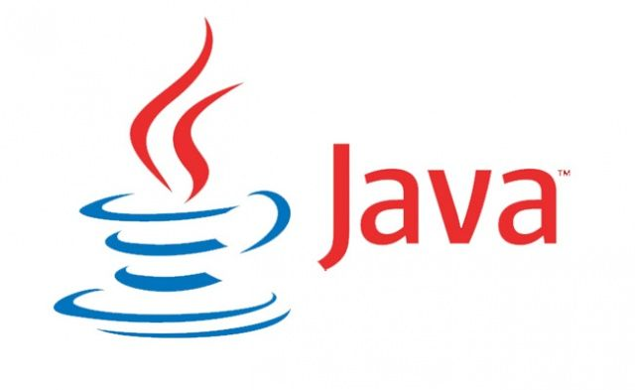

**JAVA DEVELOPER &AZUR COLUDS**

**Rameshittech**

**Chennai,medavakam,Jayachandran backside.**

**Introduction of Programming Language**

* ***we are going to learn about programming language first we have to know about the language.***

**Q.** What is language?

* Language is used by people communicate with one person to another person with their respective region. Comparing to our country each state has their own language.

Ex: Telugu, Hindi, Tamil, Kannada …etc.

Q. why do need language?

* we need the language to communicate with others to solve their daily base activities.
* Now we have to go understand about the programming language.

***Q****. what is programing language?*

* *Programming language is nothing but set of instructions which can be able to understand by the microprocessor.*
* *microprocessor is a hardware it is built/ residing in your computer which knows machine understandable language. i.e., 0’s and 1’s*

***Q****. why do we need the programing language?*

* we need programming language is require to develop the software to communicate with the hardware.
* Without programming language there is no software and without software there is no hardware, so these are the mutual understand between programming language, software and hardware.
* In the world there are so many programming languages are there.
* *Ex: C, C++, Python, .Net, java, Cobol…etc.*

*Introduction of java programming language*

***Q.*** *what is java?*

* *Java is the high-level, object-oriented, robust, secure programming language.*
* *It is platform-independent, high performance, Multithreaded, and portable programming language.*
* *It was developed by James Gosling in June 1991.*
* *It can also be known as the platform as it provides its own JRE and API.*

***Q.*** *why do we need java?*

* java helps to develop the applications with the mechanism of “Write once run anywhere (WORA) “.
* WORA means, once we compile the java source file, without re-compile we can run same compiled “.class file (byte code)” any other platforms/operating systems.

Ex: windows, Linux, IOS, macOS.

**Q. what is the use of java?**

* By using this “class-based object-oriented programming Language” we can develop 3 types of applications. They are
* Desktop application / Stand-alone applications
* Web and Enterprise applications
* Mobile applications.

Q. Why software industries mostly using java to develop a software compare to other programming languages...?

* Java is very understandable language compare to the other programming languages.
* Java is very easy process to write, compilation and execution of code compare with the other programming languages.
* In java language “code reusability feature “is introduced in java.
* In java code “Code modularity / separation of the code” feature also introduced.

*Note*:

* In “C and C++” languages are literally failed to introduced the “Code -reusability” and “Code modularity” features. this is the reason java is most powerful programming language compare to the other programming languages.

**Versions of java**

* *When introduced java in 1995 they are introduced “java Alpha and Java Beta” versions initially. But these are Unstable versions.*
* *In 1996 January 23 they are released first stable version JDK 1.0*
* *Java8 is the most useful version it is released in March 18th 2014.This code name was Spider.*
* *After java8 ,11 version software industries are used java 17 version.*
* *Now the latest version of java is JDK 21 it is released in September 19th 2023.*

**Categorization/Types of java**

* java was broadly/widely/majorly categorization into 3 types.
* J2SE (Java Standard Editon)
* J2EE (Java Enterprise Edition)
* J2ME (Java Micro/Mobile Edition)

* We can observe J2SE, J2EE and J2ME in these words 2 digit is the significant of the java number. So, they have kept 2-digit number as a trademark.

**Java Standard Edition (J2SE):**

* By using the J2SE we can develop the Stand-alone applications and Desktop applications.
* The software which we developed will be executed with in the system that we can called as Stand-alone and desktop applications.

Ex: Anti-Virus, Avastha software.

**Java Enterprise Edition (J2EE):**

* By using J2EE we can develop the Web and Enterprise / Business applications.
* The website entered URL by the user it starts with HTTP/HTTPS which we are going to develop in java those applications are called as a web / Enterprise application.
* Using this web and Enterprise applications we can access anywhere.

Ex: Amazon, Irctc, Banking applications

**Java Mobile/Micro Edition (J2ME):**

* By using J2ME Completely we can develop mobile applications only.